NOTES API END RESPONSES
- VEHICILE COLOR

WITHOUT ANY CREDENTIALS
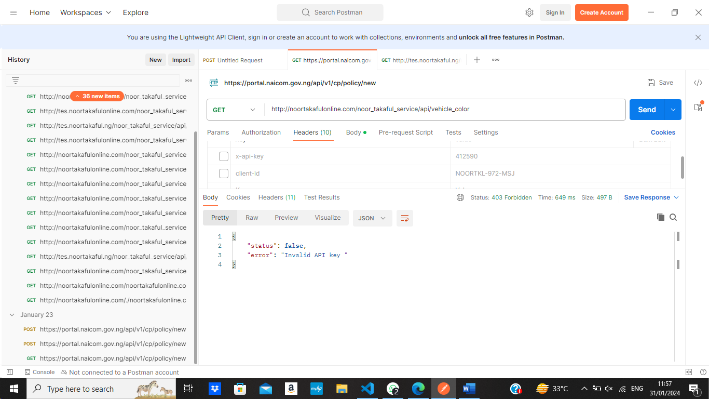

WITH WRONG CREDENTIALS
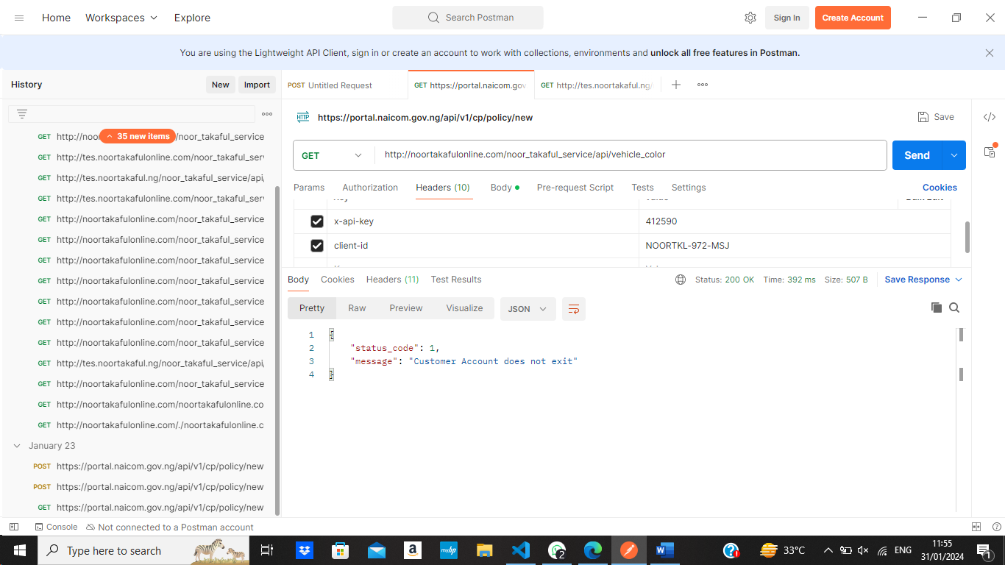

2. Vehicle CLAUSE
with wrong crendential
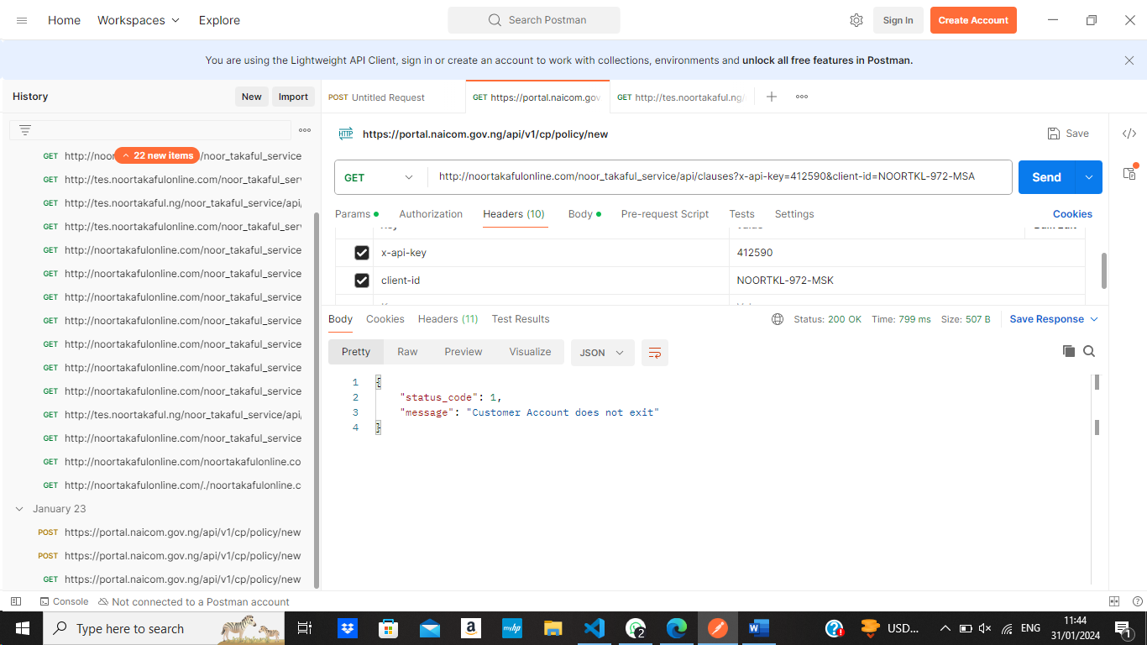

Witout any credentials
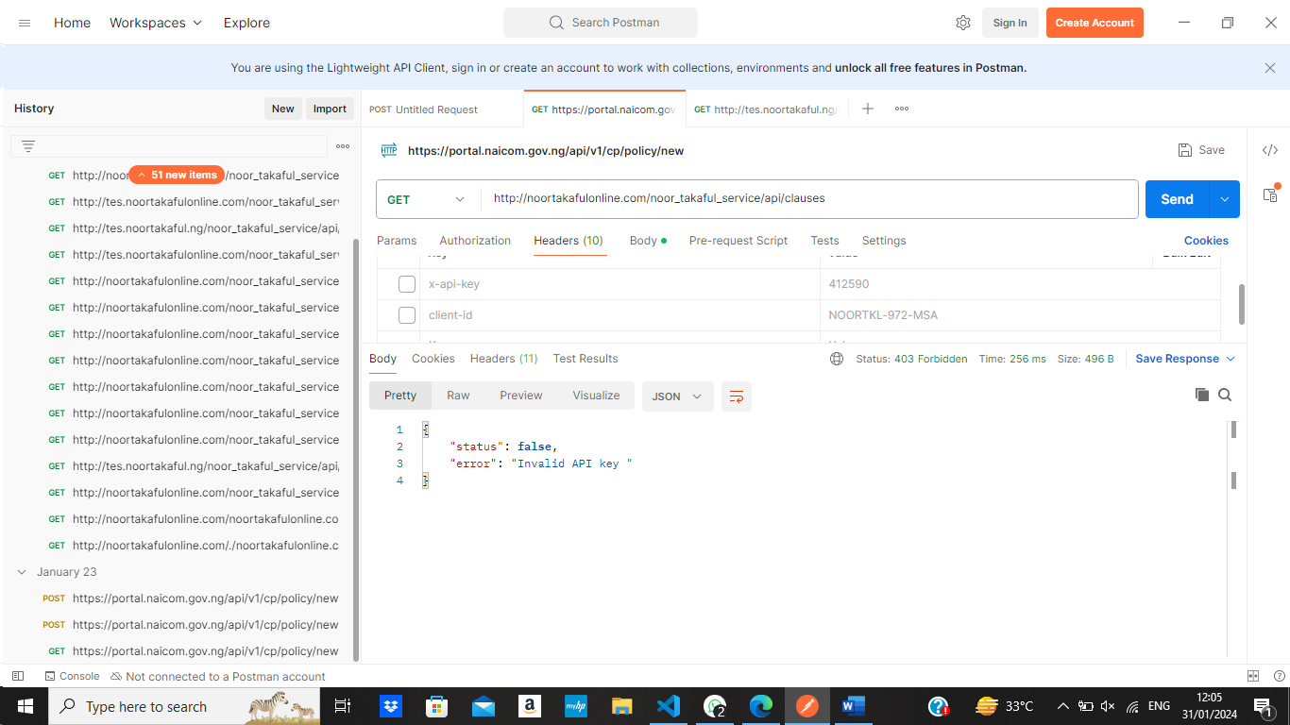

3.Vehicle Make

Without crendentials
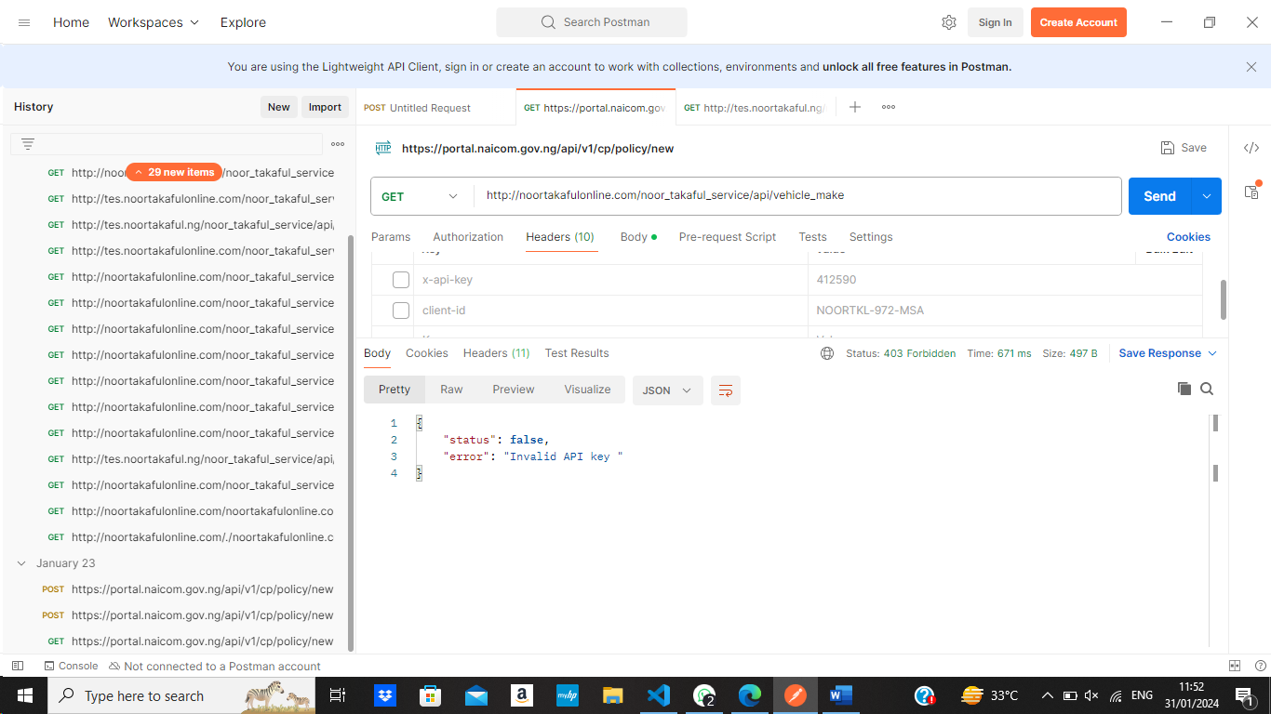

With wrong crendential
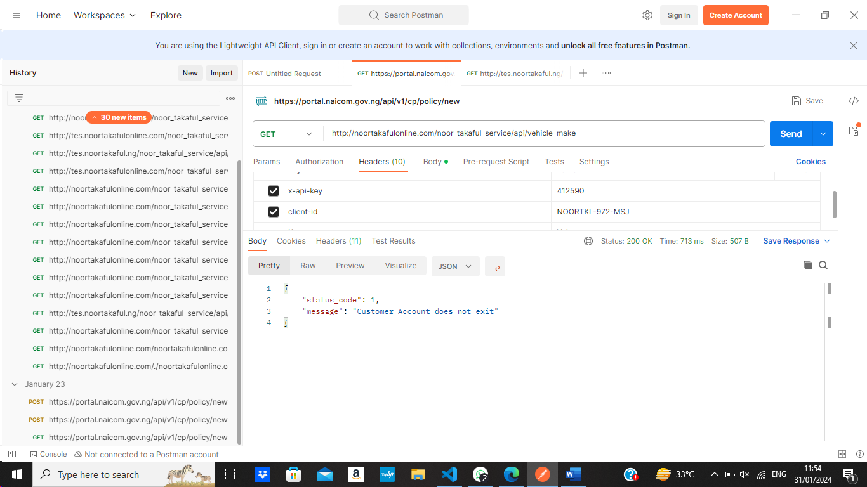

4. pers

WITHOUT ANY CREDENTIALS

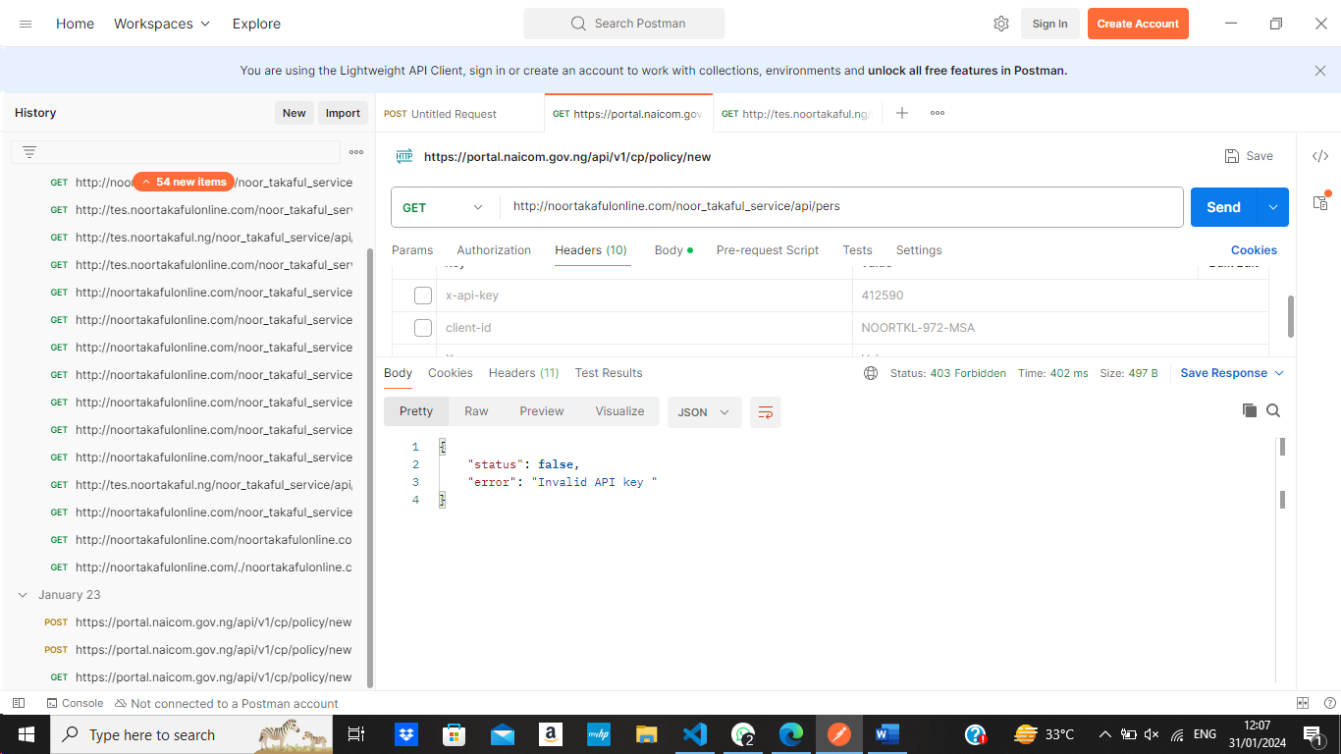
WITH WRONG CREDENTIALS
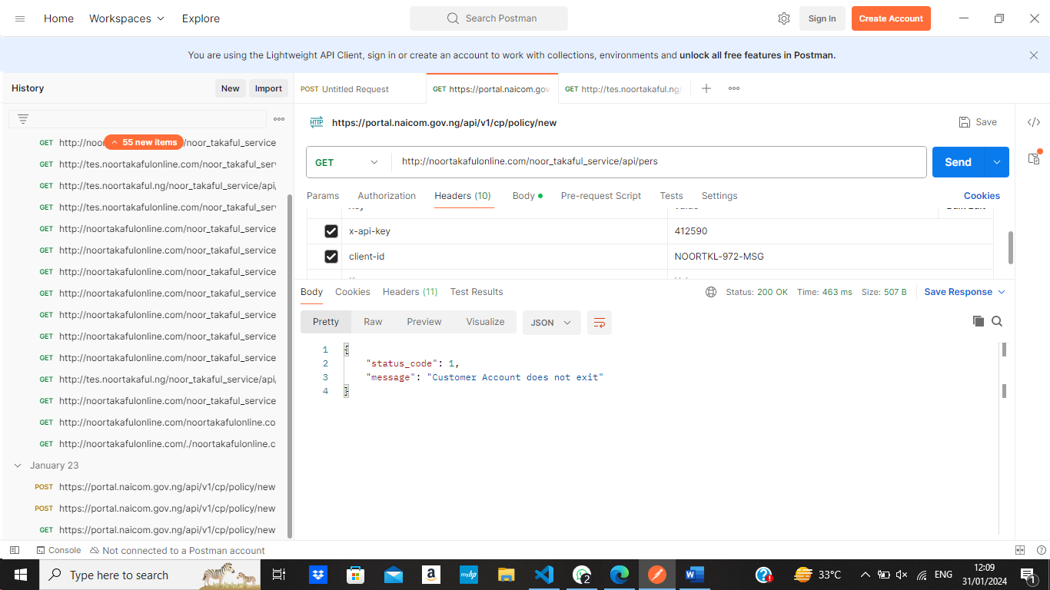

5. Packing Types (it not giving correct output on the documentation given with correct credentials )

6.. Vehicle Types

WITH WRONG CREDENTIALS
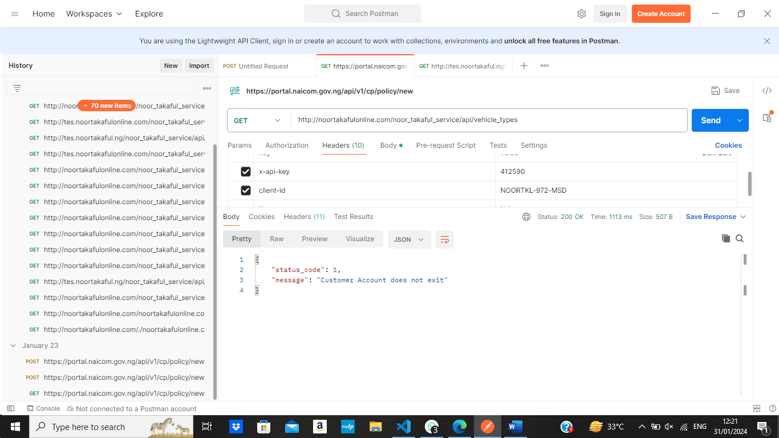

WITHOUT ANY CREDENTIALS
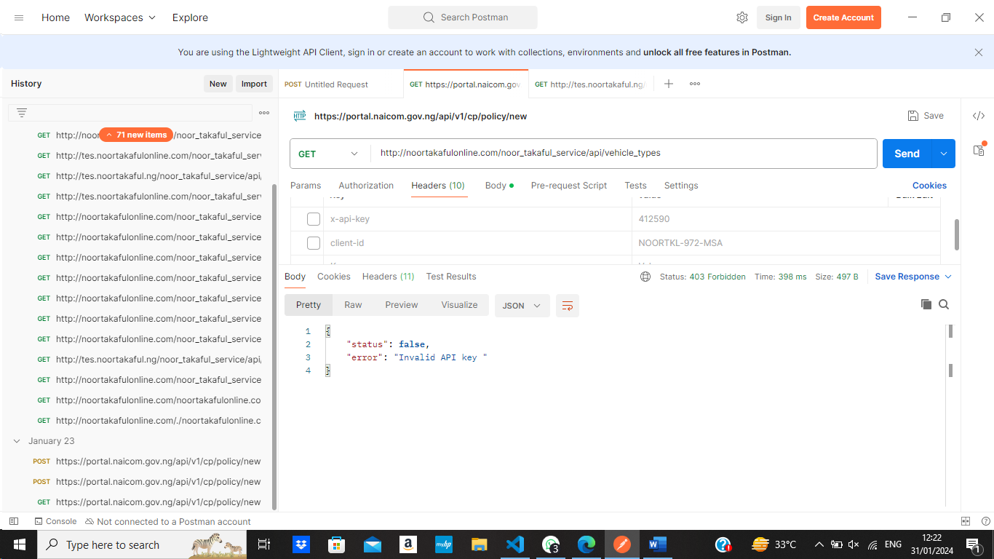

7. Insurance Policies
WITHOUT ANY CREDENTIALS
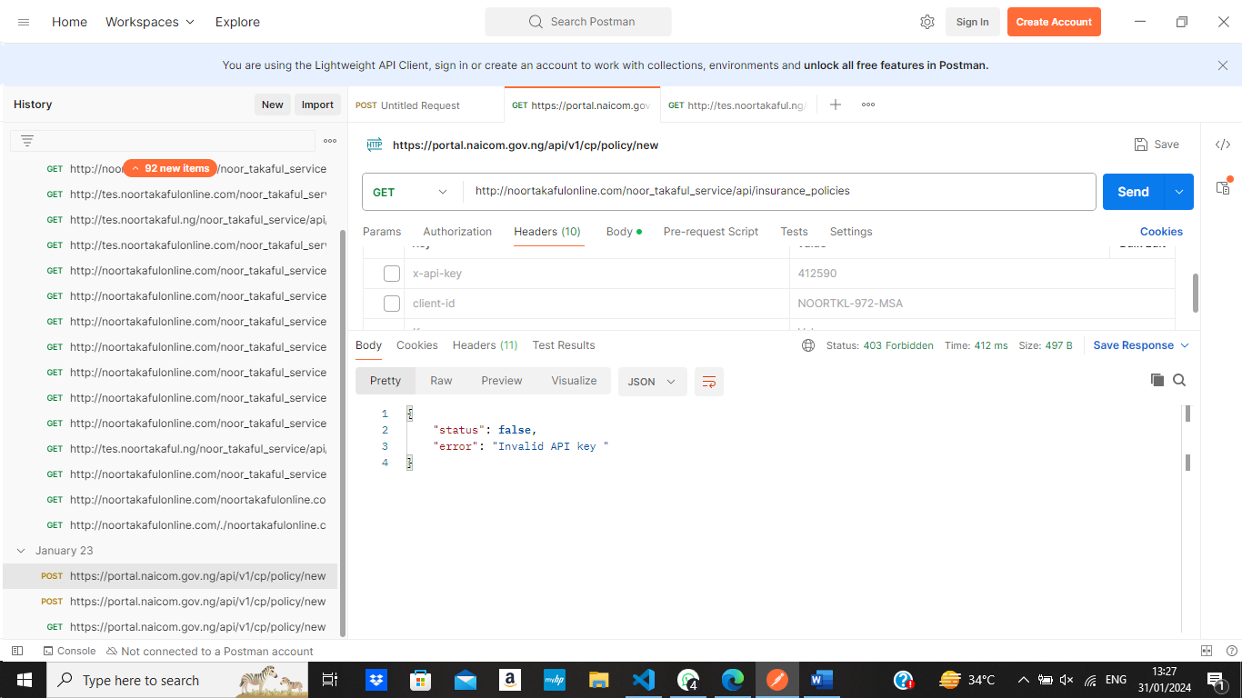
WITH WRONG CREDENTIALS
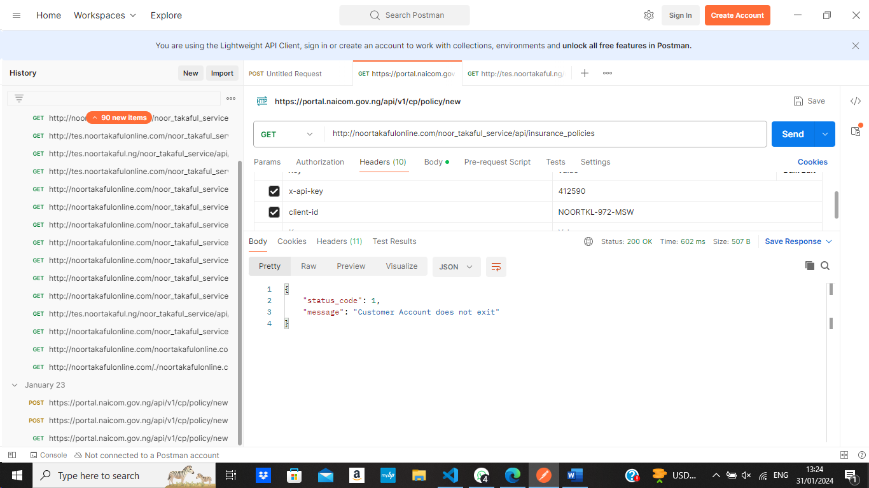

8.Insurance Types
WITHOUT ANY CREDENTIALS
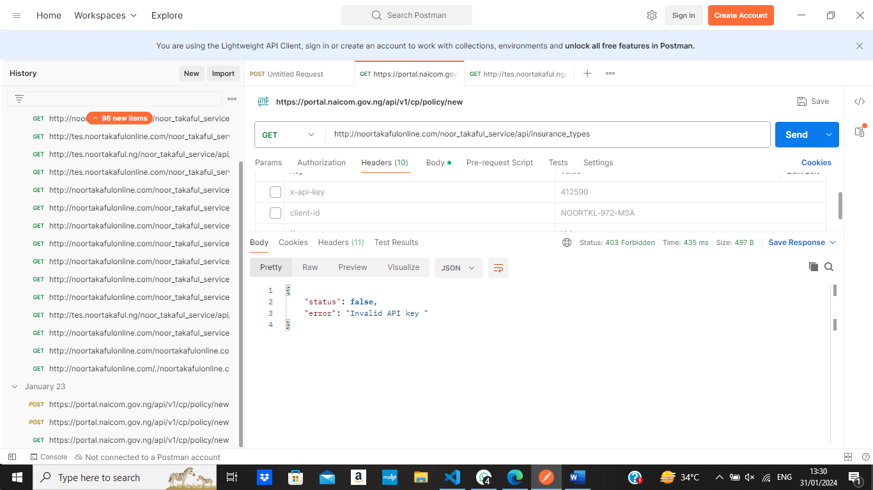
WITH WRONG CREDENTIALS
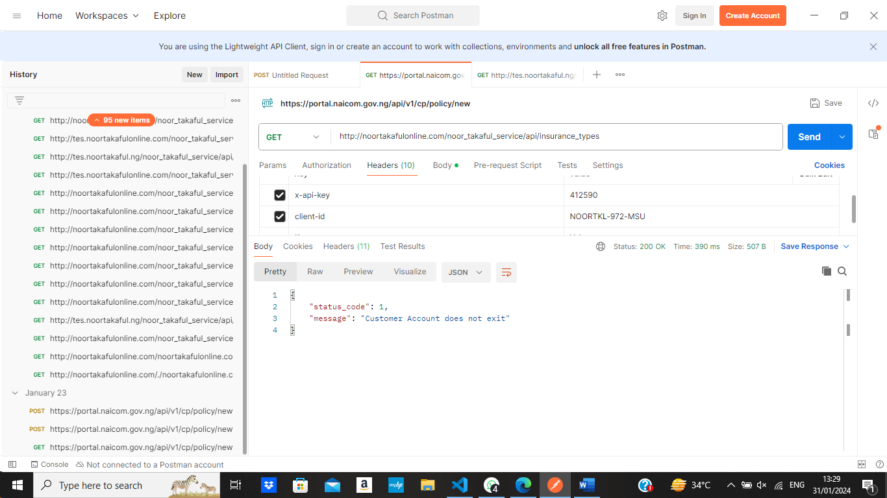

9.States
WITH WORNG CREDENTIALS
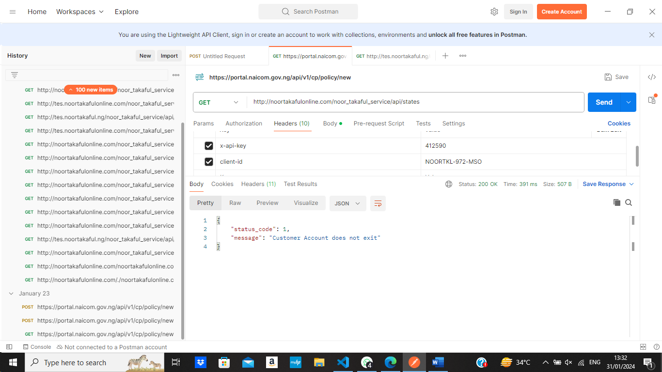
WITHOUT ANY CREDENTIALS
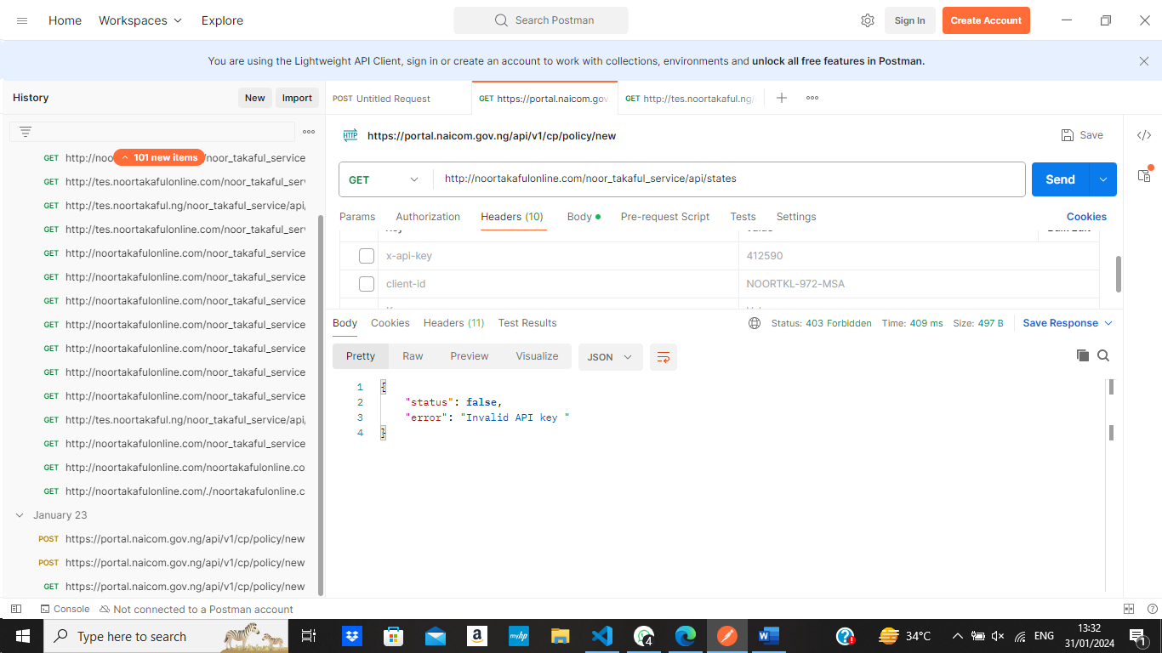

10.Vehicle categories
WITHOUT ANY CREDENTIALS
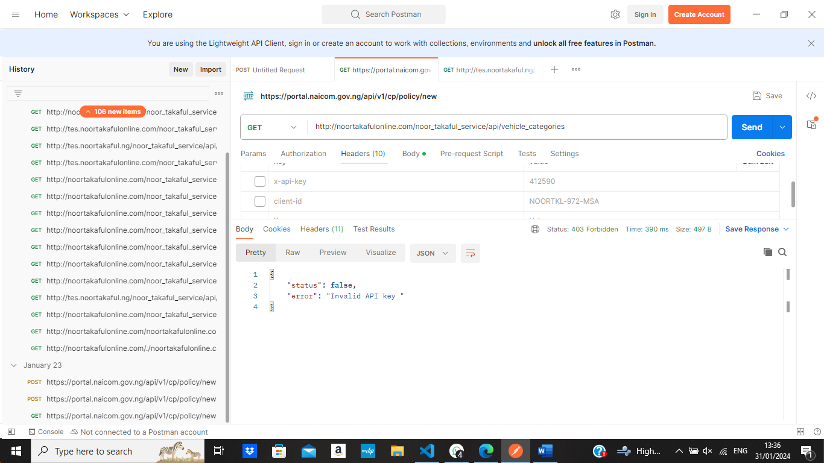
WITH WORNG CREDENTIALS
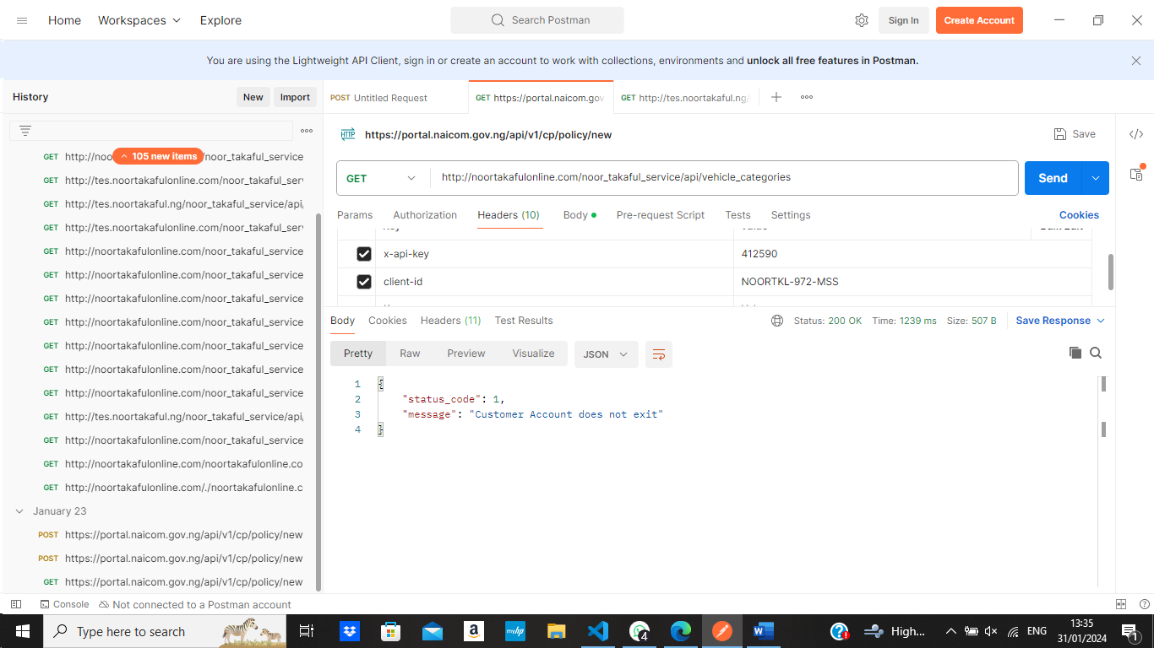

11.transaction_currencies
WITH WRONG CREDENTIALS
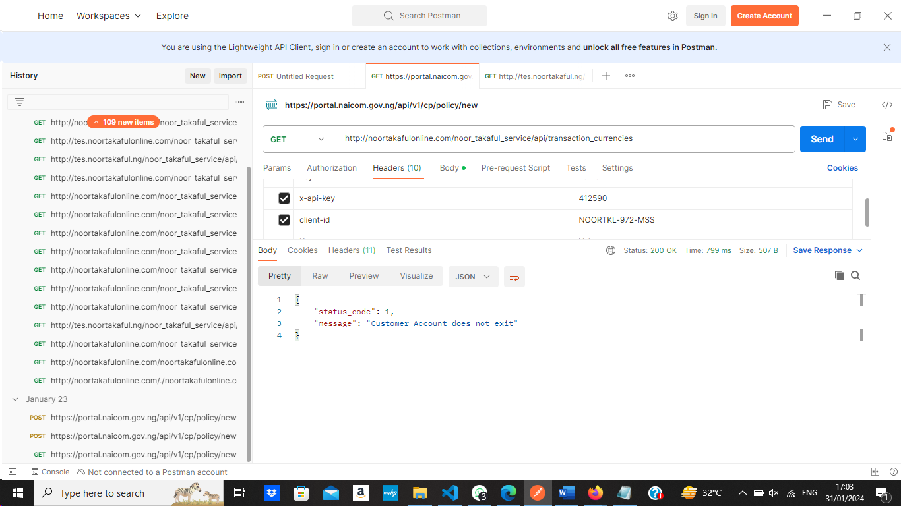
WITHOUT ANY CREDENTIALS
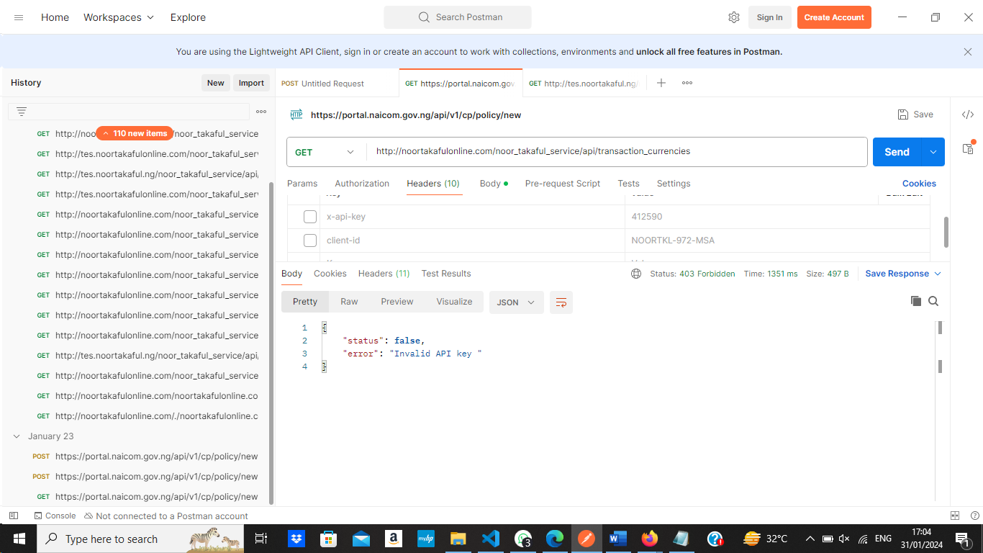

12.Vehicle Purpose
WITH WRONG CREDENTIALS
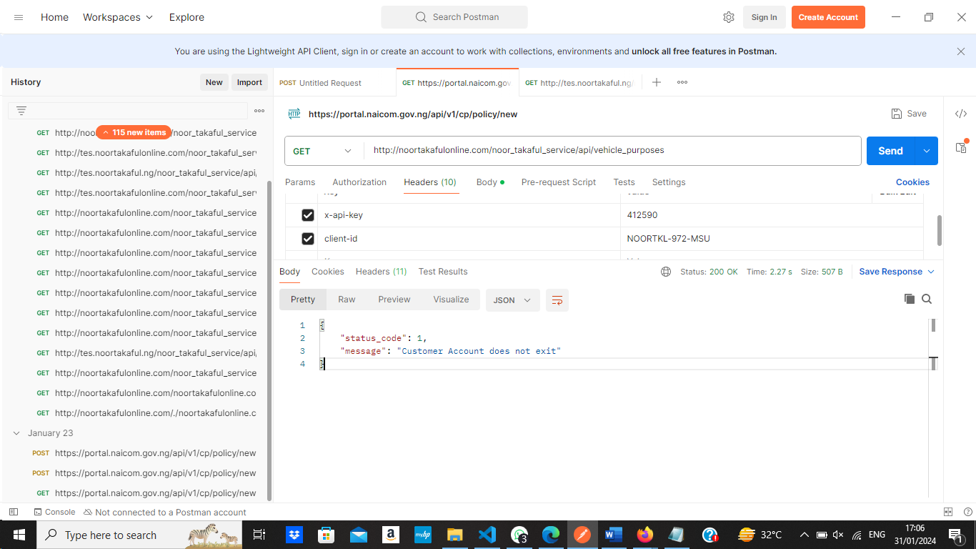

WITHOUT ANY CREDENTIALS
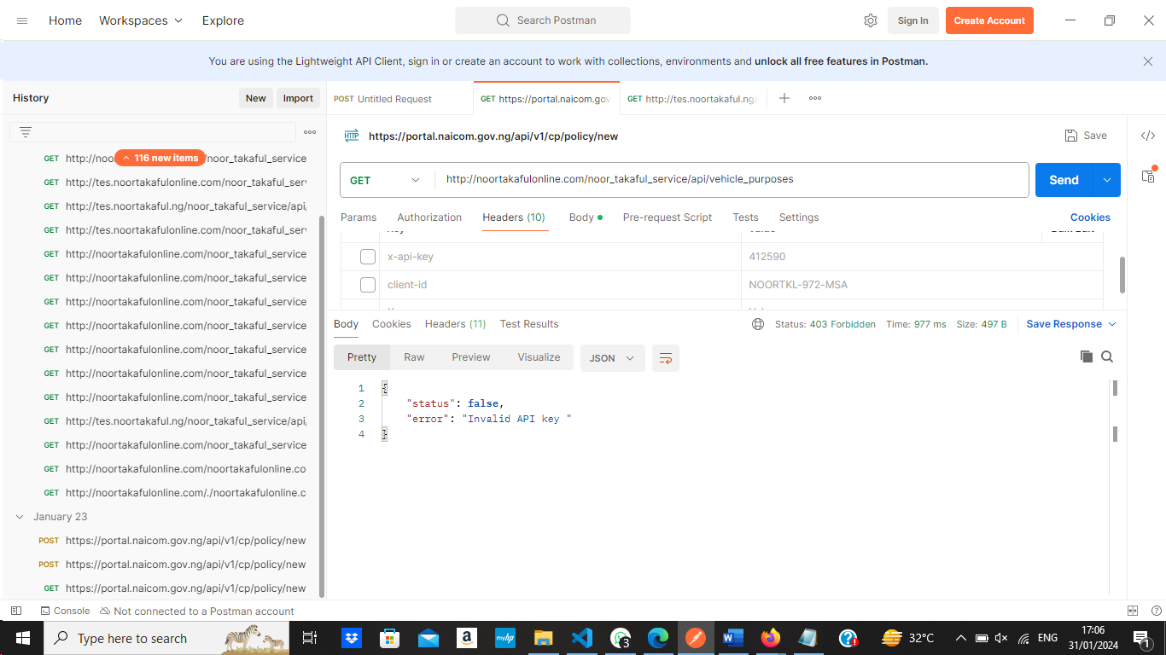

13.Vehicle Models

WITHOUT ANY CREDENTIALS

WITH WRONG CREDENTIALS

17.Voyage Destination
WITHOUT ANY CREDENTIALS
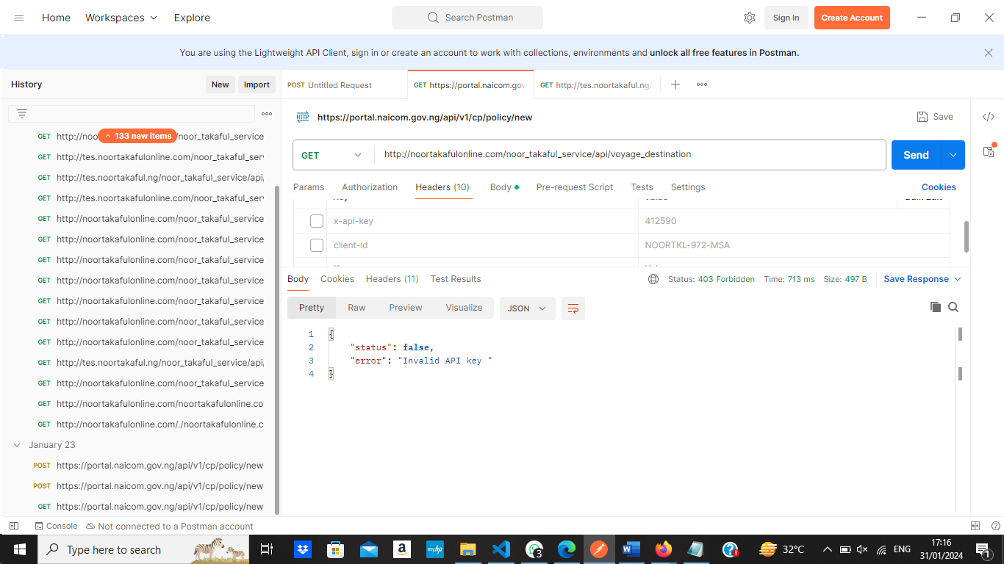

WITH WRONG CREDENTIALS
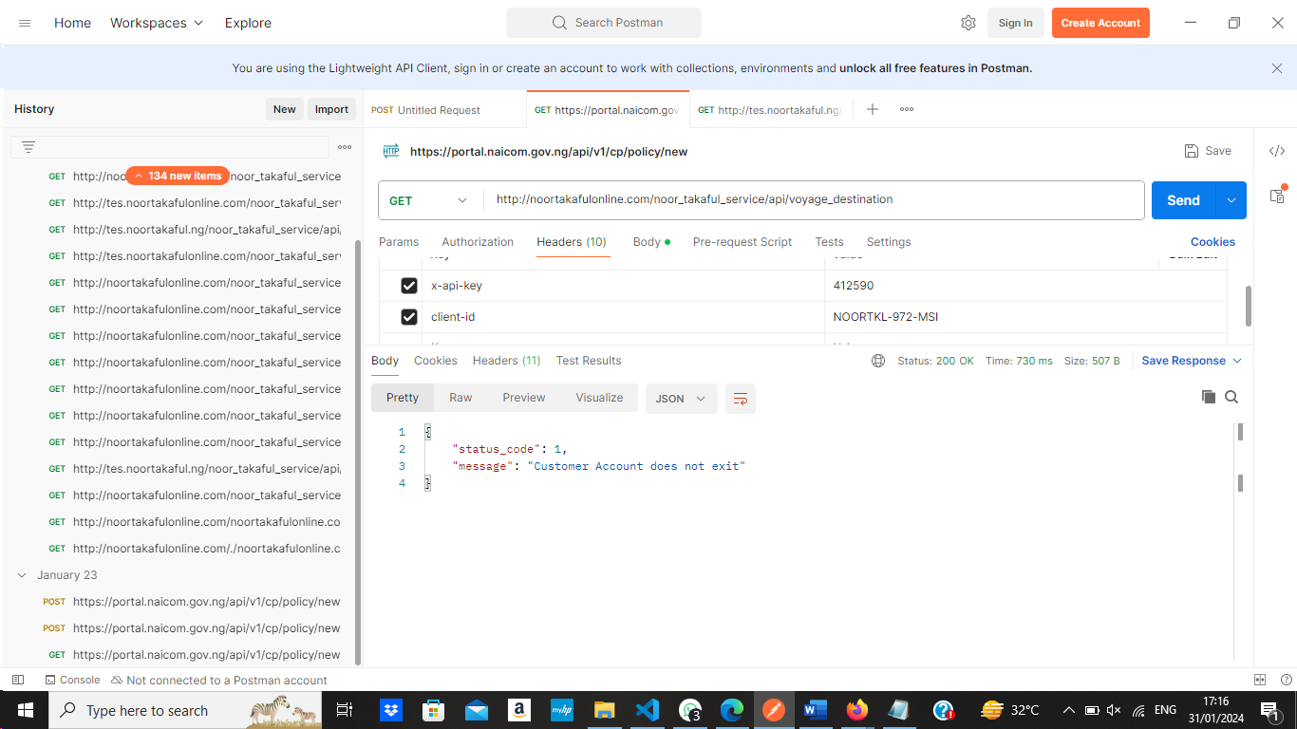

18.
WITHOUT ANY CREDENTIALS
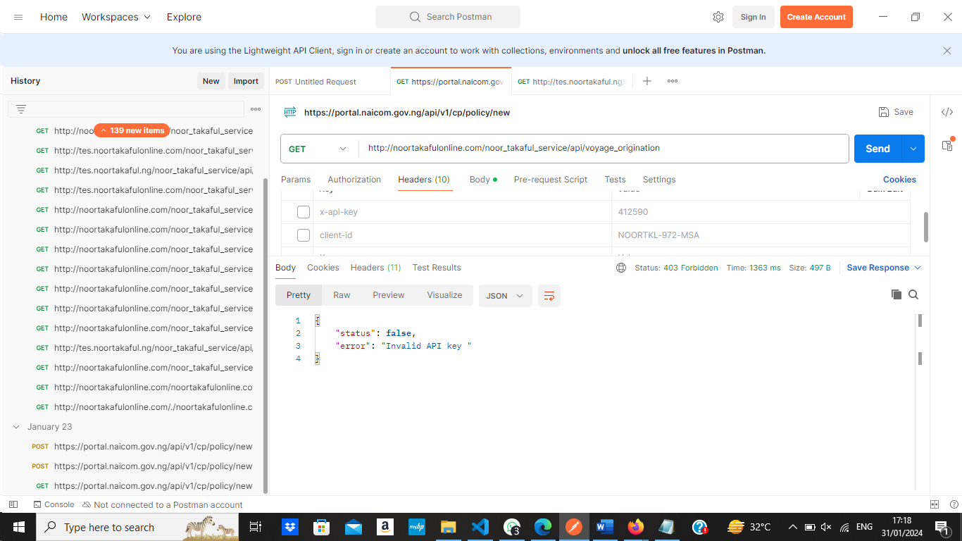
WITH WRONG CREDENTIALS
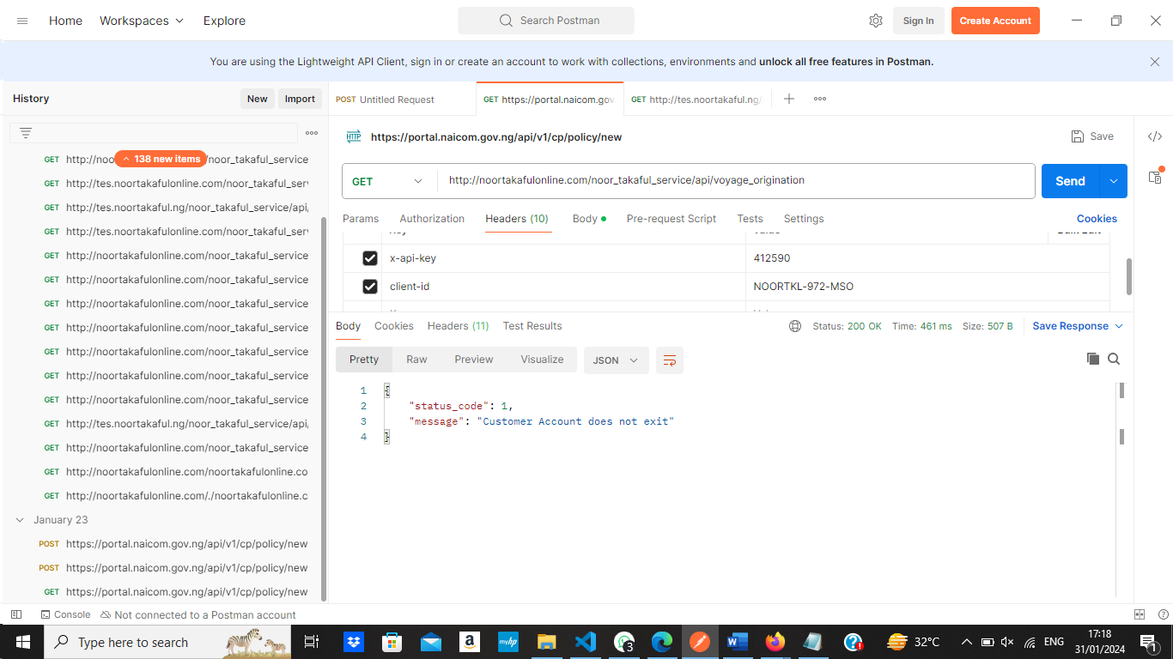

WITHOUT ANY CREDENTIALS
WITH WRONG CREDENTIALS

